Setup NFS file server on Ubuntu server VM

SSH into your ubuntu server VM and do a sudo apt update && sudo apt upgrade -y

Now, install NFS kernel server package

Create a directory to share the files on srv. You can create on another path as well.

Configure the NFS export

Define which directory is shared and who can access it in /etc/exports

Sudo vim /etc/exports then add the following line:



**/srv/nfs/shared**: This is the directory being shared.

**192.168.0.0/24**: This allows any host on the 192.168.0.x subnet to access the share. Adjust to fit your network. If you know the exact client IP, you can use something like 192.168.1.50(rw,sync,no_subtree_check). To allow all IP you can use *(rw,sync,no_subtree_check)

**rw**: Clients have read/write access.

**sync**: Ensures that data is written to disk before the server replies to the client. This is safer but can be slower.

**no_subtree_check**: Improves reliability for certain directory structures and can help avoid issues with NFS tree checks.

To apply the changes run sudo exportfs -ra

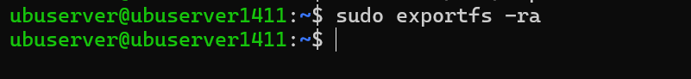

-r : Reloads/re-synchronizes the NFS export list from /etc/exports

-a : Exports all directories specified in /etc/exports

Add the rule to allow your ip range to nfs port



Use sudo ufw status to view list of rules

To verify if it works, can mount the drive locally

Sudo mkdir /mnt/testshare: create a directory called testshare in /mnt. This will be the mount point

Run sudo mount localhost:/srv/nfs/shared /mnt/testshare and if you get access denied when you try to mount



Can try adding localhost as well to /etc/exports then run sudo exportfs -ra again



After mounting, it is normal that it is still 0 items. You can create an item in source folder to verify if mounted successfully.



Create a file in /srv/nfs/shared



Some texts inside the file

Now verify if it exists in your mountpoint

You can now unmount first



Once unmounted should have no more files there in your mount point

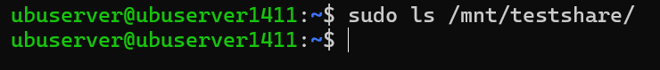

Now to try accessing our NFS share from another machine (e.g. another CentOS VM)

From our CentOS VM, update the packages first

Then install NFS utilities

Create a mount point



Mount the NFS share and then you can see the testfile.txt we created from our ubuntu server vm



